台北市立松山高中九十八學年度第二學期高一英文科第二次期中考
Part One
- 4 U: Listening comprehension 12%
Part A
Look at the pictures below. For each, you will hear one or two questions and four possible answers, A to D. Write down the letter for the best answer (A, B, C, or D).
Questions 1-2 Questions 3-4
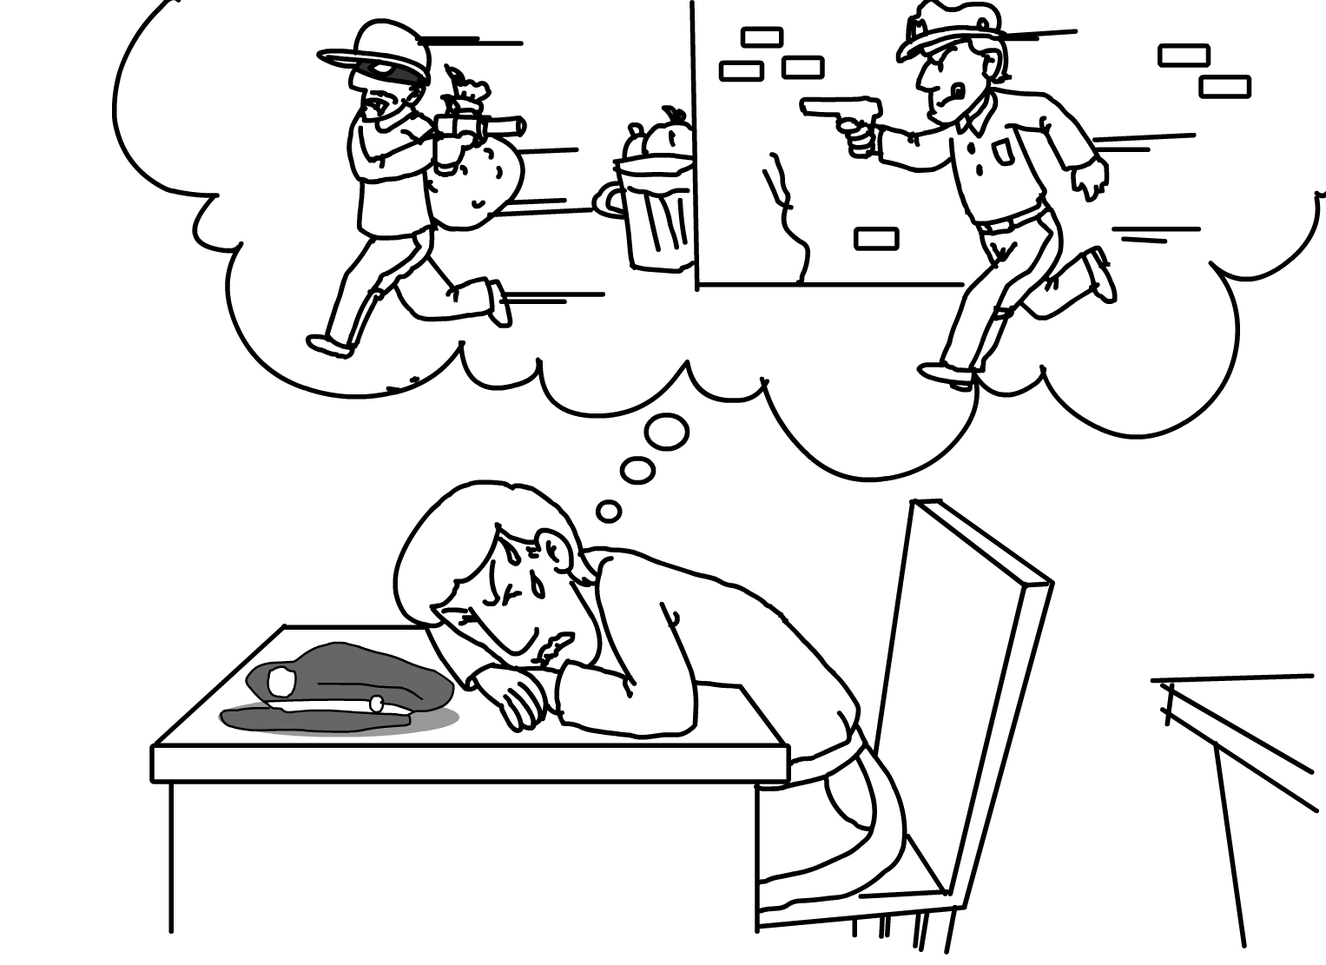


Part B
In part B, you will hear one or more questions or statements. Choose the best response or reply.
5. (A) I have a history project. (B) I need to get much fitter.
(C) I have to mail a letter. (D) I want to go home now.
6. (A) Of course; you’d do great! (B) Why didn’t they accept you?
(C) No, you haven’t finished yet. (D) I guess you could drop out now.
7. (A) He’s had a great year. (B) I think he’s moved house.
(C) Yes, he lost his business. (D) He usually stays in now.
8. (A) I’m going to spend it on a bike. (B) I might go away this weekend.
(C) I’m having a dinner party. (D) It is advertising a new car.
Part C
In part C, you will hear one or more short conversations between a man and a woman, and then a question following each conversation. Choose the best answer to that question.
9. (A) Telling the man what to do first. (B) Warning the man against something.
(C) Giving the man a list of things to do. (D) Refusing to help the man out.
10. (A) Beaches on which to relax. (B) Things that attract people.
(C) Different kinds of hotels. (D) Easy ways to get there.
11. (A) She made him do something.
(B) She helped him get into school.
(C) She helped him make a good decision.
(D) She told him he wouldn’t get a job.
12. (A) Laugh at what the man said. (B) Point out all the bad points.
(C) Try and do better than him. (D) Ask a lot of silly questions.
II. 4U Cloze 18%
(1) For young Americans, one of the most exciting times in their lives is when they get their driver’s license. Americans are very (13) cars for transportation, so they learn to drive at an earlier age than teenagers in Taiwan do. Most Americans can get a learner’s permit between the ages of 14-16. The permit (14) them to drive when adults are in the car with them. After attending driving classes and taking both writing and driving exams, they can get their license.
With the license, they can drive cars with no adult supervision. (15) , most Taiwanese must wait until they are 18 to get a license. And (16) young adults in Taiwan, many American senior high students will get a car shortly after receiving their driver’s license. With a license and a car, a young American can then enjoy a new level of freedom and (17) . No wonder getting a driver’s license is considered a rite of passage to adulthood for Americans!
13. (A) depending on (B) dependent on (C) dependable on (D) depend on
14. (A) lets (B) makes (C) allows (D) has
15. (A) In consequence (B) In addition (C) By the way (D) By contrast
16. (A) dislike (B) likely (C) unlike (D) likewise
17. (A) laughter (B) responsibility (C) durability (D) reputation
(2) Few people love nature like Silencio does. “Silencio” means silence in Spanish, but this man is (18) silent as he pronounces his love for nature. He has loved the outdoors (19) his childhood, for he grew up in the rural county of Hsinchu. Silencio and his friends listened, watched, and played with plants and animals around them. As he grew up, however, he saw how people harmed the environment. To combat this, he traveled the world to (20) understanding and love of nature.
He has traveled to many dangerous places to study nature’s beauty, sometimes narrowly (21) death! In the Amazon Rainforest, he slept in a hammock while below him walked dangerous creatures, including a tiger! These exciting experiences caused him to understand and appreciate nature even more.
Silencio wants humans to live (22) nature, not to harm it. He continues to preach his message today, educating people around the world.
18. (A) all but (B) cannot but (C) nothing but (D) anything but
19. (A) because (B) since (C) after (D) though
20. (A) instruct (B) approve (C) promote (D) respond
21. (A) escaping (B) escaped (C) escape (D) to escape
22. (A) according to (B) in harmony with (C) in conflict with (D) next to
(3) Tom Scatterhorn was sad that he had to spend this Christmas with his aunt and uncle in the small town of Dragonport. But he (23) having the adventure of his life! His relatives lived in a weird museum full of dead animals. When Tom entered it at night, the animals came (24) ! He then fell into a cupboard and went back in time 100 years earlier. He met the museum’s founder, who showed Tom a potion. This potion brought animals back to life and let them live forever!
(25) , a man from the present, Don Gervase, had also gone back in time; he wanted to get the potion from Tom. The boy escaped back to the present, but Don Gervase followed him there. He chased Tom back through time and caught him. Tom was forced (26) the portion to Don Gervase, who then revealed himself to be a giant beetle! Luckily for Tom, he went away after taking the potion and Tom returned home safely.
23.(A) picked up (B) ended up (C) summed up (D) took up
24. (A) lively (B) lived (C) living (D) alive
25. (A) Therefore (B) Moreover (C) Nonetheless (D) Otherwise
26. (A) giving (B) to give (C) given (D) give
(4) Clowns are an important part of our lives. When we need someone to cheer us up, we look to clowns. Clowns come in a variety of shapes and sizes. A famous clown that we may all be familiar with is Ronald McDonald, a famous fast food mascot. He has a fantastic (27) with white face make-up, red hair, bright colorful clothes, and big red shoes.
Actually, a clown’s look is the key (28) the attention of crowds and children. In addition to their goofy look, clowns must also be (29) and be able to make others smile. They will often perform tricks like juggling, dancing, making balloon toys, or magic.
Sometimes, however, the make-up and funny clothes may be too much for some people. Children and some adults may become scared of the sight of a strange-looking person. Sometimes, popular culture will take advantage of this fear, and make monsters of clowns, as in the case of the Joker, from Batman comic books and movies. To hide his identity, he dresses up as a clown and commits evil crimes. But being different from most clowns, he is dirty and evil. (30) the sometimes creepy side of clowns, most people still enjoy the sight of these fun-loving actors.
27.(A) custom (B) costume (C) customer (D) costumer
28.(A) to catch (B) to be catching (C) to be caught (D)to catching
29.(A) lifelike (B) innocent (C) stubborn (D)entertaining
30.(A) Though (B) Despite the fact that (C) In spite of (D) Although
- Focus On 15 %
31. Several people, unable to accept the decision of the vote, got up and ___ out of the meeting.
(A) blinded (B) stormed (C) satisfied (D) humid
32. Robert has a big ___. He eats two times as much as his brother.
(A) expense (B) hammer (C) appetite (D) claw
33. On the basis of Greek mythology, Minotaur was a ___ that was half human and half bull.
(A) pardon (B) monster (C) alphabet (D) structure
34. The professor’s experiences have been so different from others that it’s difficult for them to ___ to him.
(A) agree (B) inform (C) remain (D) relate
35. People must ___ the traffic rules. Nobody should be an exception.
(A) treasure (B) paste (C) admit (D) observe
36. Lucy ___ something about a travel plan next month, but she didn’t offer further information.
(A) mentioned (B) concerned (C) supposed (D) admired
37. Although they didn’t succeed in their earlier ___ to reach the top of the mountain, they made it in the end.
(A) audience (B) attempt (C) attitude (D) account
38. The trunk of the tree seems ___; however, it is hollow.
(A) skinny (B) solid (C) sore (D) specific
39. One of my classmates was elected to ___ us to attend the TV program.
(A) represent (B) recognize (C) react (D) respond
40. The ___ of the teenagers are supportive of the game; only some hold different opinions about it.
(A) technique (B) majority (C) dinosaur (D) column
41. The ___ of many old customs remain unknown. In other words, we have no ideas how they started.
(A) origins (B) opportunities (C) offense (D) ovens
42. The moment my eyes fell upon the escaped bear, I almost died from ___.
(A) mission (B) fright (C) blouse (D) receipt
43. Apart from feeling ___ from time to time, I enjoy traveling abroad.
(A) homesick (B) obvious (C) various (D) technical
44. The workers were busy digging a new railway ___ through the mountain.
(A) pillow (B) climate (C) tunnel (D) channel
45. The rock singers paid a visit to Taiwan for their brand new ___.
(A) steam (B) nephew (C) napkin (D) album
IV. Textbook Cloze: 17 %
- Nowadays, people suffer from the trouble caused by the computer viruses. One of the computer viruses is a Trojan, sometimes (46) a Trojan horse, which is designed to allow a hacker remote access to a target computer system. The term (47) the Trojan War. As the name suggests, the main battle was (48) the Greeks fought hard for their queen taken away by Paris, the Trojan prince. The Greek army had a hard time defeating their enemies although they were led by Achilles. It was because Troy (49) such huge walls that they failed to (49) . With the hint given by Athena, the Greeks made and left a giant wooden horse in front of the city. Fooled by the Greeks’ trick, the Trojan king made the wrong decision (50) . The Greek army returned and burned the great city to the ground.
46. (A) is called (B) is thought of (C) referred to as (D) looked up to
47. (A) is associating with (B) has concerned about
(C) has connecting on (D) is related to
48. (A) Troy, the place which (B) at the city of Troy, which
(C) in Troy, where (D) occurring in the city, Troy
49. (A)surrounded…getting into it (B) was surrounded by … take it over
(C) surrounding…to have entered it (D) which surrounded …took it over
50. (A) having cause the country to destroy
(B) resulted in the country to fall
(C) which had resulted from the fall of the country
(D) leading to the destruction of the country

- Mr. Wesley went to the fortune-teller, Madame Rosa’s office. What (51) him visit her (51) he was troubled by a mental problem. (52) for the solution for years, he expected that he could get the answer he wanted. As soon as he sat down, he said, “ I wish I (53) I was a man or a woman in my last life.” He explained that on the basis of the (54) , men liked to share facts and general information mostly. However, he founded that he tended to focus on feelings and details. After listening to what he said patiently, Madame Rosa concluded that what mattered was not one’s gender. Instead, she added, “It is important for us all to accept the gender differences (55) our happiness depends on (55) one another.
51. (A) let… was because (B) enabled…owing to
(C) caused… because (D) made… was that
52. (A) To be searching (B) To have been searched
(C) Been in search (D) Having been searching
53. (A) know whether or not (B) would know if
(C) knew whether (D) had known what
54. (A) long-existing gender stereotypes (B) long-existed stereotype genders
(C) length-existing gendered stereotypes (D) existed-lengthy stereotype genders
55. (A) as…the reason why to understand (B) for… how much do we understand
(C) for…the way do we understood (D) as…how much we understand
(3) Most of us have been told to do or not to do something since we were little. For instance, if we run into a black cat, we’d better turn around, and we ought not to open an umbrella indoors. Sometimes we do know (56) we should or shouldn’t do these things. However, most of the time, we just follow customs which are based on some superstitions. A superstition is a false belief (57) one event leads to – or – prevents another when the two are far from related. Do you know why breaking a mirror will bring us bad luck? According to some unknown resources, breaking a mirror is said (58) his or her own reflection, which will do harm to his or her soul. (59) opening an umbrella indoors, it comes from the idea that an umbrella is a protector against the storms of life. Once you open one in your home, the household guardian spirits will think you feel their protection is not enough, and (60) . Everyone in the house will then be cursed without the protection from the spirits. There are still (61) long-practiced superstitions besides what is mentioned above. It’s really hard that we make sure if they are meaningful or just nonsense, (62) ? Since we fear what we don’t understand and we cannot find out scientific proof to support or break these superstitions, maybe it is best for us to follow these customs.
56. (A) how (B) when (C) why (D) where
57. (A) , that (B) that (C) , which (D) which
58. (A) that breaking (B) to break (C) that to break (D) to be broken
59. (A) Instead of (B) In addition to (C) On account of (D) As to
60. (A) leaving in anger (B) took off immediately
(C) never will they come again (D) they were stuck in the house then
61. (A) a great amount of (B) the number of
(C) a large number of (D) a good deal of
62. (A) doesn’t it (B) don’t we (C) aren’t they (D) isn’t it

V. Cloze 5 %
Nowadays, talent shows are in. (63) It is easy to find similar programs worldwide. (64) Compared with the super stars in the show business, those joining in the talent shows look less gorgeous and charming. (65) Believe it or not, a counterpart of them also appears in Taiwan. (66) His video on Youtube caught the Taiwanese media’s attention. (67) According to the news, Lin has been invited to attend the late-night talk show on TBS hosted by George Lopez. Isn’t this an impossible dream come true?
(A) Called Taiwan's Susan Boyle, chubby Lin Yu Chun is well-known for belting out Whitney Houston's I Will Always Love You.
(B) Two of the typical cases, Paul Potts and Susan Boyle, arouse the international attention for their powerful voice and plain appearance.
(C) That is, many ordinary people take part in such TV programs to demonstrate their talents.
(D) Before long, Lin has not only become an Internet hit but made a name for himself abroad.
(E)For example, Englishmen enter Britain's Got Talent, the Americans join American Idol, and the Taiwanese participate Super Star Avenue.
VI. Reading Comprehension 8%
“Better City, Better Life,” which expresses the common goal of mankind to improve urban environments, is the theme of the 2010 World Expo in Shanghai, China from May 1st to October 31st. Held every five years, the World Expo has always been the third largest event in the world since 1851, when it first took place in the Crystal Palace in London. Countries, international organizations, and even thousands of individual citizens take part in these memorable events to celebrate the world’s many unique cultures and technological developments.
The tallest and most visible pavilion belongs to the host country. The China Pavilion sits at the center of the Expo, for it is known as the “Oriental Crown.” The color, “Forbidden City Red,” was chosen to be symbolic of the spirit of Chinese culture. Japan, famous for its vehicle products, put i-REAL, a one-passenger vehicle from Toyota, and Panasonic’s “Life Wall” in its pavilion. Drivers can ask the i-REAL to move just like a human’s arms and legs, and “Life Wall” offers people a chance to see the future when people will be able to make a television screen appear anywhere in their homes. Taiwan is also represented at the Expo with its own theme, “Mountain , Water, Lantern of Heart.” The Taiwan Pavilion, looking like a sky lantern, is actually a see-through cube which can be a screen with a giant globe in the center. A four-minute movie about Taiwan’s culture and beautiful scenery will be shown inside the globe. It’s indeed a great opportunity for people in other places to know Taiwan more.
The World Expo, undoubtedly, has shown people around the world that we definitely share common hopes and dreams regardless of our differences.

68. What is NOT related to China according to this passage?
(A) The Oriental Crown. (B) The Forbidden City.
(C) The host Country. (D) The Life Wall.
69. Which sentence is CORRECT based on this passage?
- The first World Expo took place 159 years ago.
(B) The World Expo is the largest event in the world.
(C) The Taiwan Pavilion is a sky lantern with a massive cube in the heart.
(D) The next World Expo is going to be held in 2014.
70. What can we learn from this passage?
- The World Expo gives us little chance to know more about other countries.
(B) However different we are, we all have a dream that the earth will be better.
(C) Crystal Palace is the next place to host the World Expo.
(D) The “Life Wall” of Toyota can move like human’s arms and legs.
71. What is the BEST title for this passage?
- Shanghai, a Cultural and Traditional City.
- China Grows in Its Popularity via the World Expo.
- The History of the World Expo.
- World Expo, an Event that Shows You the Characteristics of the World.
Part Two
- Vocabulary and derivatives 15 %
1.In my opinion, before you make your final decision, you really have to take your family’s safety into c n.
2.Do not i e others in our arguments. You and I are who should figure out the solution to our problems.
3.With the a h of Chinese New Year, stores are crowded with shoppers.
4. The children stared at each other angrily as they f t over which TV program to watch.
5. The g n gap is a term concerning differences between parents and their children.
6. According to the reporter, n s people rushed into the Taipei World Trade Center for the Taipei Tourism Exposition and caused the traffic jam.
7. The math teacher managed to explain the question carefully to avoid unnecessary m g.
8. What you need to do now is c e the plan as soon as possible. It’s time we carried it out.
9. Long time ago, kings of small countries used to d e war on their neighbors.
10. To convince us of your chemical experiment, you need to show some s c evidence.
11. It is not easy to draw a (conclude) because the opinions are so different.
12.As the saying goes,“(prevent) is better than cure,” doing some exercise every day is better than taking medicine after you are sick.
13. Bob showed me ten ways to avoid (destruction) a computer in all kinds of accidents.
14. The evil woman yelled something (harm) at the helpless kid.
15. Who can tell me what is the biggest fish in (exist)?
II. Translation (每格都不只一個字) 10 %
1. Tommy looked at the cake fresh from the oven (1) .
湯米看著剛出爐的蛋糕流口水。
2. Watching the horror movie Ring (2) .
看了恐怖電影「貞子」讓我毛骨悚然。
3. Mr. Lee gave his wife a bouquet of roses for helping him deal with (3) .
李先生送他太太一束玫瑰作為共同處理人生的起伏。
4. No one (4) with a perfect solution so far.
目前為止沒人想出完美的解決方法。
5. Bill is on the way to the teacher’s office. The (5) he looks for the teacher (6) he feels troubled about the club activity. He has a strong desire for a successful performance in public. However, the practice he did every day last week caused him (7) in class. He knows very well that he (8) other’s help. Therefore, he wants to talk to his teacher because he worries that his mom (9) if he gets poor grades in the midterm exam. Consequently, he decides to (10) his teacher for advice.
比爾朝著老師辦公室走去。他去找老師 (5) 的理由 (6) 是他對社團活動感到困擾。他強烈渴望成發的成功。然而，上禮拜每天的練習導致他上課時 (7) 睡著了。他非常清楚他 (8) 需要別人的幫忙。因此，他想跟老師談，因為他擔心如果他段考考差了，他媽媽 (9) 可能痛哭。因此，他決定 (10 )求助於他的老師。

台北市立松山高中九十八學年度第二學期高一英文科第二次期中考

答 案 卷

Class: __________ No:__________ Name:_________________

Part Two
- Vocabulary and derivatives 15 %

1. | 2. | 3.
4. | 5. | 6.
7. | 8. | 9.
10. | 11. | 12.
13. | 14. | 15.

Translation 翻 譯 10% (一格不只一個字，全對才給分。)

(1). | (2).
(3). | (4).
(5). | (6).
(7). | (8).
(9). | (10).

