台北市立松山高中九十七學年度第一學期第一次期中考 高一英文科
請將答案劃記在答案卡上
Part One English 4U magazine (the September issue)
Listening Test 10%
Part A
Look at the pictures below. For each, you will hear one or two questions and four possible answers, A to D. Write down the letter for the best answer (A, B, C, or D).
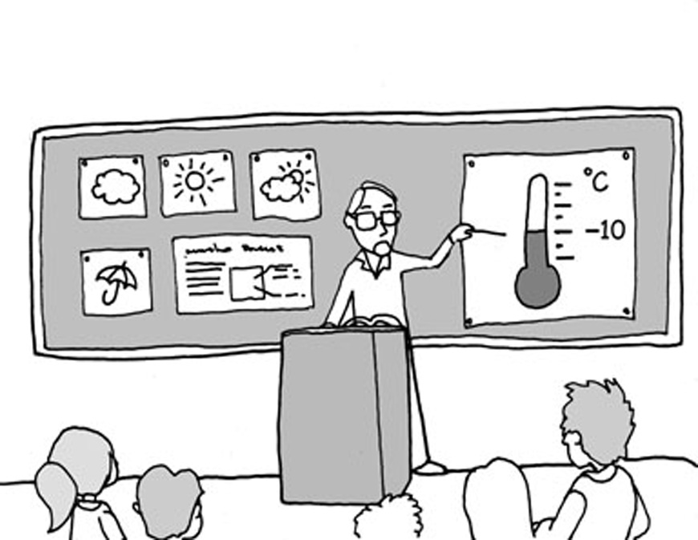
Questions 1-2

1. ______ 2. ______

Part B
In part B, you will hear one or more questions or statements. Choose the best response or reply.
3. (A) I’m glad he will give it back to her.
(B) I knew he wouldn’t give it back.
(C) Why would he lie to her about it?
(D) I hope she gives him his money back.
4. (A) No, having a seat would be better.
(B) No, but I will climb it one day.
(C) Yes, I got the new job.
(D) Yes, I wish I had one before.

Part C
In part C, you will hear one or more short conversations between a man and a woman, and then a question following each conversation. Choose the best answer to that question.
5. (A) That ABC is a bad thing to call people.
(B) That ABC means American born Chinese.
(C) That children should learn their ABCs.
(D) That ABCs usually live in America.
6. (A) There are few wild animals there.
(B) She wanted to study wild animals.
(C) Many wild animals live there.
(D) She is afraid of wild animals.
7. (A) She’s happy the man got the job.
(B) She’s afraid the man will lose his job.
(C) She’s surprised the man got a job.
(D) She doesn’t think the man needs a job.

Part D
In part D, you will hear one or more passages and then some questions about them. Choose the best answers to those questions.
8. (A) They were scared of attackers.
(B) They are not often seen these days.
(C) They were very heavy animals.
(D) They were very short animals.
9. (A) They were small and weak.
(B) They were big and strong.
(C) They were big and lazy.
(D) They were small and clever.
10. (A) People from cold places.
(B) People who solved problems.
(C) People who were very old.
(D) People from a long time ago.

Reading Test
I. Vocabulary & phrases 10%
11. A huge wave crashed over the rocks and ______ the people standing near the water.
(A) soaked (B) noticed
(C) shut (D) welcomed
12. The meal will ______ a salad and a drink at no extra charge.
(A) attend (B) experience
(C) include (D) locate

13. Before the important game, the players were ______ walking back and forth.
(A) narrowly (B) increasingly
(C) formally (D) nervously
14. Jim ______ his friend to a game of basketball and won by a score of ten to nine.
(A) shocked (B) contacted
(C) deserted (D) challenged
15. ______ relaxation, the couple decided to take a vacation and lie on the beach for a week.
(A) Pulling (B) Seeking
(C) Begging (D) Maintaining
16. For a real ______ experience, the students decided to travel through Europe for the summer.
(A) cultural (B) humble
(C) official (D) polite
17. Rob said Tina looked great in her new dress, and she appreciated the ______.
(A) joke (B) hope
(C) compliment (D) statement
18. If you love surfing, then Hawaii, with its high waves, will be a ______ for you.
(A) chemical (B) paradise
(C) judgment (D) search
19. The campers made a lot of loud noises to ______ the bear.
(A) take away (B) put away
(C) move away (D) drive away
20. Saving up your loose change can ______ a lot of money over time.
(A) move on to (B) take up to
(C) add up to (D) last up to

II. Choose the best answer from below to fill in each blank 5%
(A) think of (B) popular with (C) searching for
(D) in front (E) showed up (F) showed off
(G) familiar with (H) in public (I) hear from

- Joe’s girlfriend finally flew into a rage when he _____ one hour late to the party.
- All the villagers were _____ the missing child.
- Alan didn’t enjoy singing _____. She has a problem with stage fright.
- Mike hoped to _____ his niece often, so that he could know about her college life.
- In order to win the games, the players should get _____ the rules first.

Part Two Textbook Lesson 1-4
I. Cloze Test (30%)
(A) My family life was happy until one January day. That morning, I heard my mom running up the stairs, __26__ out my name. __27__ I saw tears in her eyes, I knew there was something wrong. I ran downstairs and found my father __28__ on the floor. I called 119 and the medics got to my home in a few minutes. They gave my father a quick exam, put him in the ambulance __29__ him to the hospital. At the hospital, the hours __30__ like years. It seemed that I could do nothing but wait. During that time, I tried to make a deal with God. I promised I would trade everything I wanted __31__ Father’s recovery and that if he __32__ my father, I would no longer ask for anything. Luckily, my prayer __33__. I had my father back. He recovered from his stroke and returned home.
I didn’t realize how much I loved my father __34__ I almost lost him. I believed that I had learned a lesson—never take __35__ for granted that your parents will always be there for you.
26. (A)cry | (B)cried | (C)to cry | (D)crying
27. (A)On | (B)If | (C) As | (D) Although
28. (A) lie | (B) lying | (C) lay | (D) lied
29. (A) rushed | (B) and rushes | (C) but rushed | (D) and rushed
30. (A) spent | (B) cost | (C) took | (D) dragged
31. (A) for | (B) at | (C) on | (D) with
32. (A) spired | (B) sold | (C) spared | (D) ignored
33. (A) came right | (B) was answered | (C) was true | (D) was asked
34. (A) until | (B) while | (C) since | (D) before
35. (A) that | (B) something | (C) it | (D) X

(B) If you want to develop your ability __36__ yourself in English, here are some suggestions to follow. First of all, you need to listen to English you can understand as __37__. Start with a radio or TV program __38__ your level; it will be not only helpful __39__ enjoyable. If you don’t understand every word or sentence in it, don’t __40__ it. Switch your attention to what you understand and try to __41__ what you have heard and then repeat it as well as you can. Never worry about your pronunciation or grammar. Just be a copycat! __42__, never forget to use English to communicate in daily situations! That is, you should __43__ every chance possible to talk with people in English. Talk to a foreigner or a classmate, join an English club, take part in a speech contest─all will push you to use English in real communication. Don’t be afraid of __44__. You should try to learn __45__ communicate easily and comfortably. When you can do it, you’ll find your English improving day by day!

36.(A) in expressing | (B) of expressing |  | (C) to express | (D) for expressing
37.(A) as possible as you can |  |  | (B) as more as possible
(C) as frequent as you can |  |  | (D) as frequently as possible
38. (A) at | (B) in |  | (C) for | (D) as
39. (A) and | (B) also |  | (C) as well | (D) but
40. (A) be crazy about | (B) be amazed at |  | (C) take interest in | (D) get hung up on
41. (A) ignore | (B) mimic |  | (C) exaggerate | (D) remove
42. (A) In addition | (B) Beside |  | (C) However | (D) As a result
43. (A) look up | (B) look out |  | (C) look for | (D) look to
44. (A) not understanding him |  |  | (B) making mistakes
(C) calling them fools |  |  | (D) being successful
45. (A) what to |  | (B) how to | (C) where to | (D) when to

(C) To be popular is an important issue for many teenagers. For most of them, being popular means __46__ part of an in-crowd. They want to be accepted as a member of a group. In fact, the true sense of being popular really lies in the fact __47__ you can be yourself and get along with different sorts of people. It is important to be yourself. When people like to be with the real “you”, it means that they like you for __48__ you really are. __49__, they may like you for your talents, your personality, or your kindness. That’s __50__ more important than trying to be in by wearing the same clothes, or doing the same things as others. Besides, if you want to be liked by everyone, __51__ nice to everyone. Take the initiative to greet anyone you know and start a conversation with a friendly smile on your face. That’s usually how friendship begins. What’s more, learn to like yourself and be confident __52__ yourself by finding something you are __53__ doing. Then people will definitely be __54__ you. To sum up, the key to __55__ popular is to be real, friendly and confident.

46. (A) to be | (B) being | (C) you are | (D) having
47.(A) that | (B) which | (C) and | (D) as if
48. (A) which | (B) how | (C) who | (D) whether
49. (A) Additionally | (B) Therefore | (C) Likewise | (D) For example
50. (A) very | (B) rather | (C) far | (D) quite
51. (A) are | (B) being | (C) be | (D) to be
52. (A) in | (B) of | (C) with | (D) on
53.(A) good in | (B) at home on | (C) expert in | (D) good for
54. (A) attracting for | (B) attracted to | (C) attracting to | (D) attracted for
55. (A) being | (B) be | (C) feel | (D) appear

II. Choose the best answer from below to fill in each blank (7%)
(A) through (B) but (C) unlike (D) give in (E) to write by
(F) turn in (G) writing with (H) For another (I) and (J) like

E-mails are really helpful and convenient to students. For one thing, students can __56__ their reports or assignments by using e-mails and get back the corrected copies in the same way. They can also practice __57__ the help of e-mails. If their spelling is wrong and there are some mistakes in grammar, the computer will point them out and even correct them. Writing on a computer is just __58__ having a personal writing tutor. __59__, students can easily keep in touch with their friends __60__ e-mails. They can type all their messages on the computers and then send them out. Usually, they can receive the replies quickly. Furthermore, __61__ talking on the phone, they have more time to choose the right words in front of a computer. Besides, using e-mails is cheaper than talking on the phone. Using e-mails has many benefits, __62__ students shouldn’t be indulged in it and forget what they should do.
III. Matching (10%)
63. Amazingly, I found my new car
64. In order to master a foreign language
65. As soon as I entered the bookstore
66. Unlike most old men
67. How I wish

- I was at the party.
- parking in front of the convenience store.
- I had bought the best-seller yesterday.
- ,the beautiful background music interested me.
- English is used to communicate with others frequently.
- ,Nancy has won the swimming contest.
- taken away by the police.
- ,so I practiced constantly.
- ,Tom is crazy about rock music.
- ,we have to study it as hard as possible.

IV. Reading comprehension (4%)
Too many of us do not find happiness or live life to the fullest because of a lack of self-acceptance. Self-acceptance is an agreement with yourself to appreciate, accept and support who you are at this very moment, even those parts you’d like to eventually change. Many people have the wrong belief that if they accepted themselves as they are, they wouldn’t change or that they wouldn’t work on becoming more of who they want to be. We tend to think that if we don't accept ourselves, then that will be a motivation to change what we don't like about ourselves.
However, the truth is that if you will go for self-acceptance right here, right now, then all of those things that you felt will make you happier will come to you once you let go of the need to have them to live your life to the fullest. So, from now on, you may look honestly at your beliefs about yourself and about others. Let go of the need to be someone else, or to look a certain way. Accept the fact that you are a unique individual that is worthy of self love. Give yourself permission to love and accept yourself for now and then you can decide what you want to improve on in the future. If you can really accept yourself as you are right now, then some day you will look with wonder at the miracles that will happen once self-acceptance is firmly rooted in your being.
68. What is the main idea of the article?
(A) It is important for us to learn to accept others.
- If we accept ourselves as we are, we won’t change.
- Lack of self-acceptance will result in happiness and change.
- Self-acceptance is of benefit to our life.
69. The author gives us the following suggestions for practicing self-acceptance except_________.
(A) Accepting the fact that you are a unique person worthy of self love
(B) Looking at your beliefs about yourself honestly
- Trying hard to give up your bad habits
- Accepting yourself as you are and decide what you want to improve on in the future

以下答案請寫在答案卷上

V. Vocabulary and derivatives (15%)
70. My sister is tall, energetic and a______c; she is good at sports and enjoys all kinds of outdoor activities.
71. With a heart-warming story and beautiful music, the movie “Cape No.7” is very i_______e. That is why the movie attracts lots of moviegoers in Taiwan.
72. G_____e smiles and manners will help us to win friendship. That is to say, when making friends with others, it is important to be sincere and friendly.
73. Keeping a diary in English and listening to an English magazine broadcast are e_____e ways to learn English.
74. It was just an o_______y weekend for us; nothing special or exciting happened.
75. Lots of girls are t______ed of cockroaches. That is why they always scream when they see one.

76. The goal of each school is to treat students as individuals and help each student to achieve their full p______l.
77. The Golden Gate Bridge is the most popular man-made tourist a______n in the U.S.
78. Most parents pay close attention to the physical and mental d_______t of their children to make sure that they grow up happily.
79. It is a Chinese c_______m to give children red envelopes during the Chinese New Year.
80. John and Mary are a happy couple and they are always ________ (support) of each other.
81. It is _________ (benefit) to eat fresh fruits and vegetables every day.
82. Nick and his three travelling _________ (company) had a wonderful adventure in Africa.
83. By reading different kinds of good books, we can correct our _______ (ignore).
84. Last winter vacation was _______ (memory) because my whole family went on a trip to Japan.

VI. Translation (9%) (毎格不只一字, 毎格全對才給分)
1. 往昔，我的祖母住在遙遠的小鎮; 她堅持要我在暑假時拜訪她，陪陪她。
In the past, my grandmother lived in a distant small town; she ___85____ my visiting her during summer vacation to k_____86_____.
2. 我非常喜歡我祖母。她是很棒的廚師，並以她的廚藝為傲。
I liked my grandmother very much. She was an excellent cook and she t____87____ her cooking skills.
3. 此外，祖母很有幽默感並且喜歡和商家討價還價。
Moreover, my grandmother had _____88_____ and liked to ____89_____ shopkeepers.
4. 每當我想起祖母，她的燦爛微笑就浮現我的腦海，我突然笑了出來。
Whenever I thought of my grandmother, her bright smile _____90____ and I ____91______.
5. 祖母常告訴我要盡量善待父母，以回報他們對我的愛
She often told me to treat my parents _____92____ to repay their love for me.
6. 她和我分享她的人生哲學，要做為人生的贏家，就必須為成功努力。
She shared with me her philosophy of life—“Being a winner in life means w_____93_____.”

台北市立松山高中九十七學年度第一學期第一次期中考 高一英文科
答案卷 班級: 座號: 姓名:

V. Vocabulary and derivatives (15%)
70. athletic | 71. impressive | 72. Genuine | 73. effective
74. ordinary | 75. terrified | 76. potential | 77. attraction
78. development | 79. custom | 80. supportive | 81. beneficial
82. companions | 83. ignorance | 84. memorable

VI. Translation (9%) (毎格不只一字, 毎格全對才給分)
85. insisted on/ was insistent on | 86. keep her company
87. took pride in | 88. a great sense of humor
89. bargain with | 90. came to mind/came into my mind  flashed into my mind  went through my mind  crossed my mind
91. burst into laughter  burst out laughing | 92. as well/nicely as possible  as well/ nicely as I could
93. working hard for success

1-5 ACACB 6-10 CACBD 11-15ACDDB 16-20 ACBDC
21-25 ECHIG 26-30 DCBDD 31-35 ACBAC 36-40 CDADD
41-45 BACBB 46-50 BACDC 51-55 CBCBA 56-62 FGJHACB
63-67 GJDIC 68-69 DC 52題選A 也對

