Part A 18%
Look at the pictures below. For each, you will hear one or two questions and four possible answers, A to D. Write down the letter of the best answer (A, B, C, or D).
Question 1
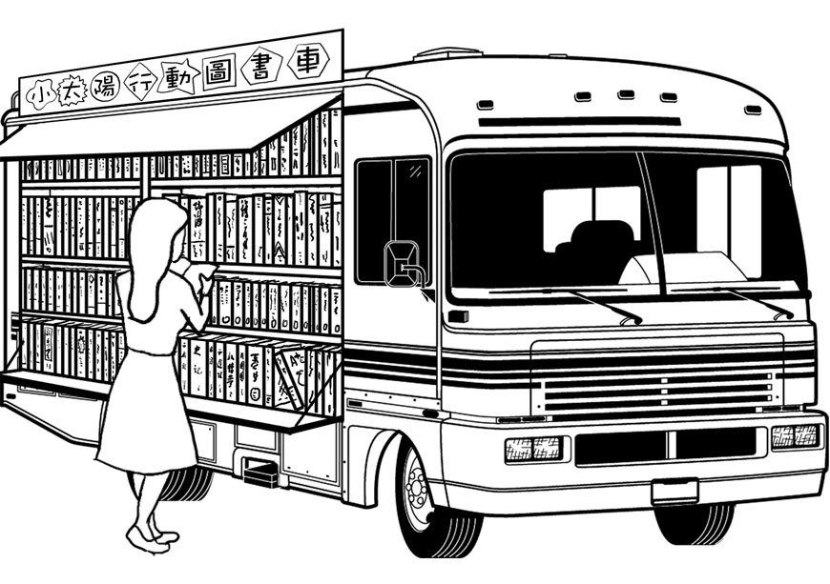

1._____
Question 2
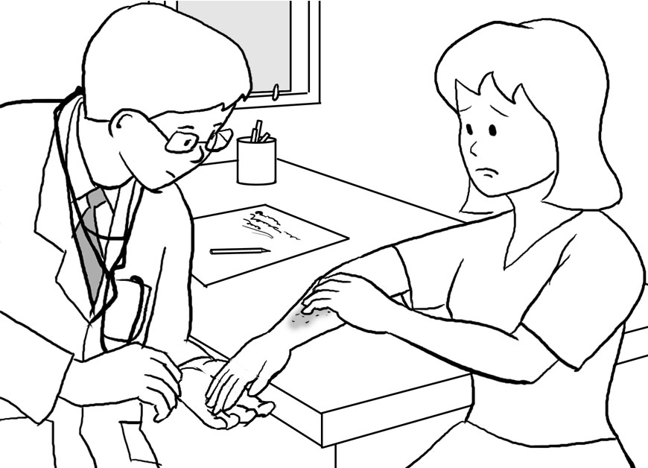

2._____
Question 3
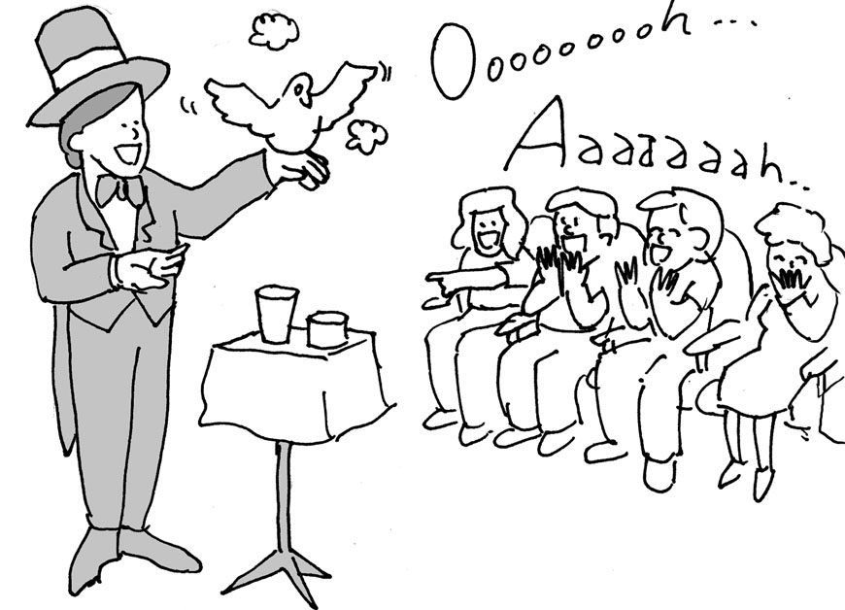

3._____
Question 4
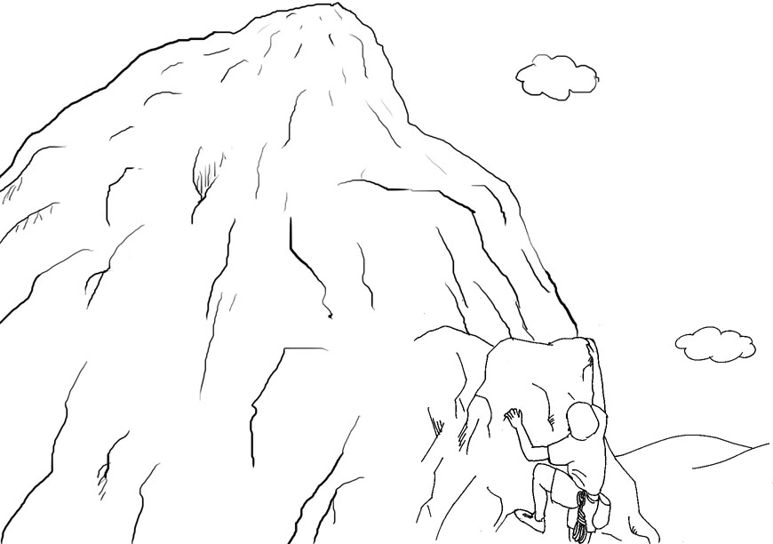

4._____

Question 5
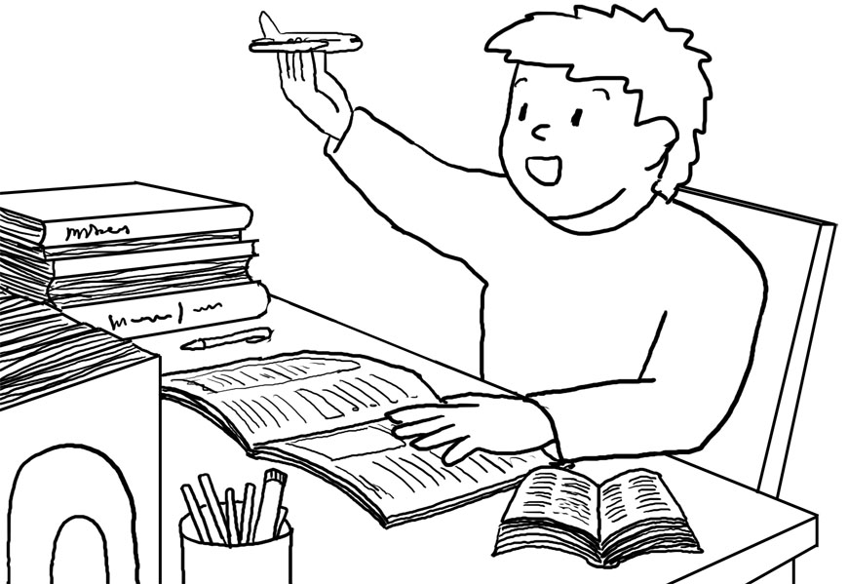

5._____
For Questions 6-9, look at the pictures, and then listen to the questions about the pictures and the THREE possible answers. Choose the best answer for each question.
Question 6
臺北市立松山高中101學年度第一學期高一第一次段考英語聽講試題
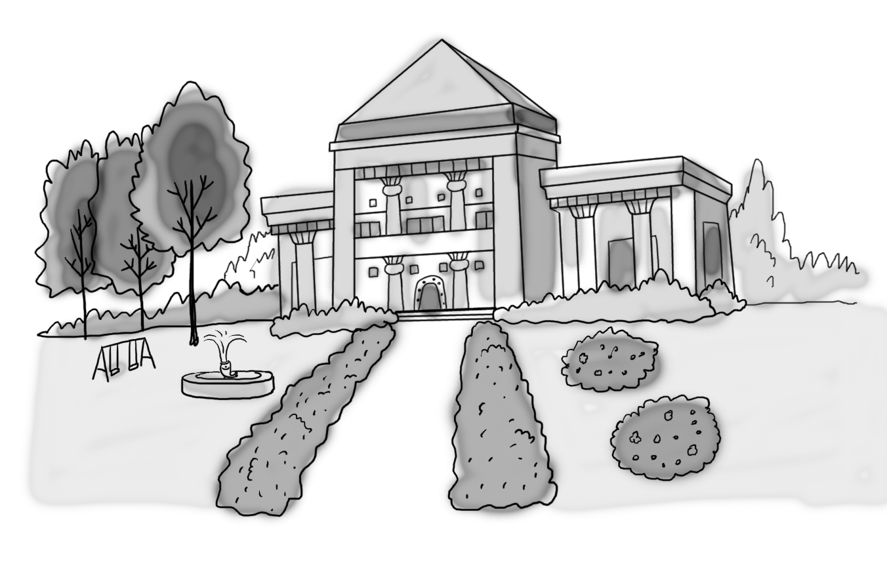

B 6. Is the store next to the park?
6._____
Question 7
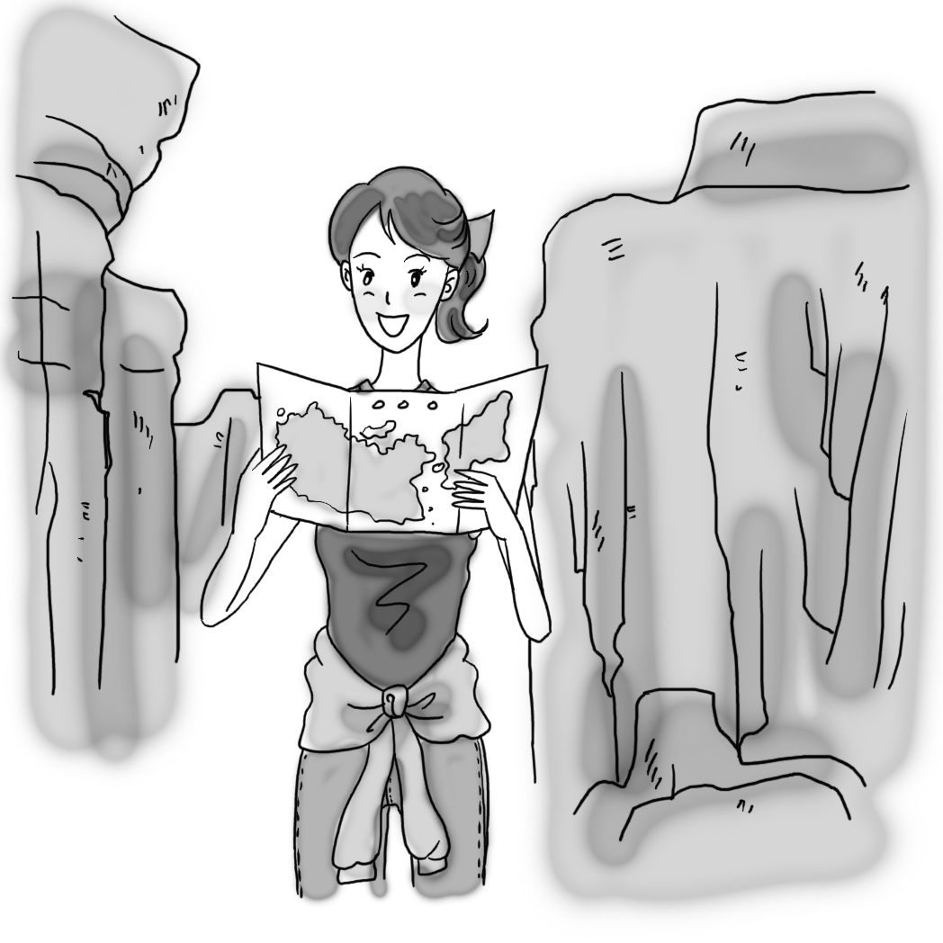

7._____
For Question 8, please look at the following three pictures. Listen to the following message for Sofie. Which country is she from?
Question 8
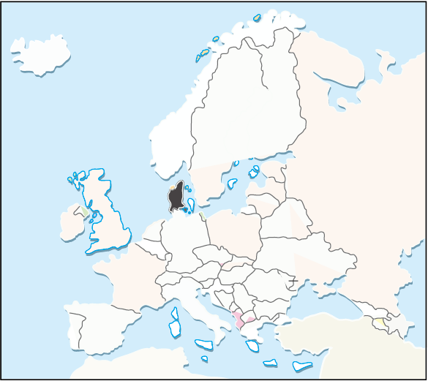
A. B. C.

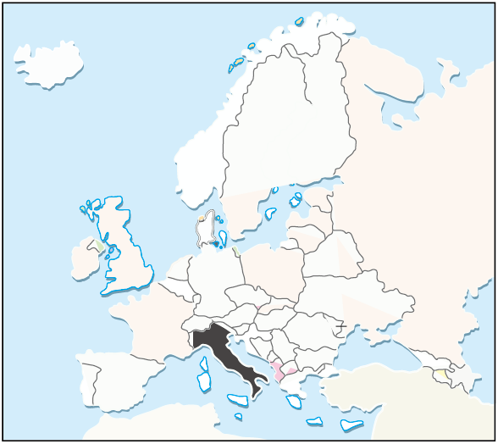
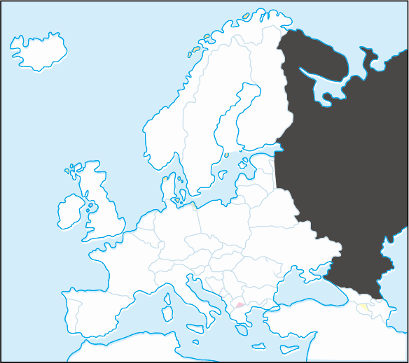
8._____
For Question 9, please look at the following three pictures. Listen to the following short talk. Where will Noriko most likely go?
Question 9
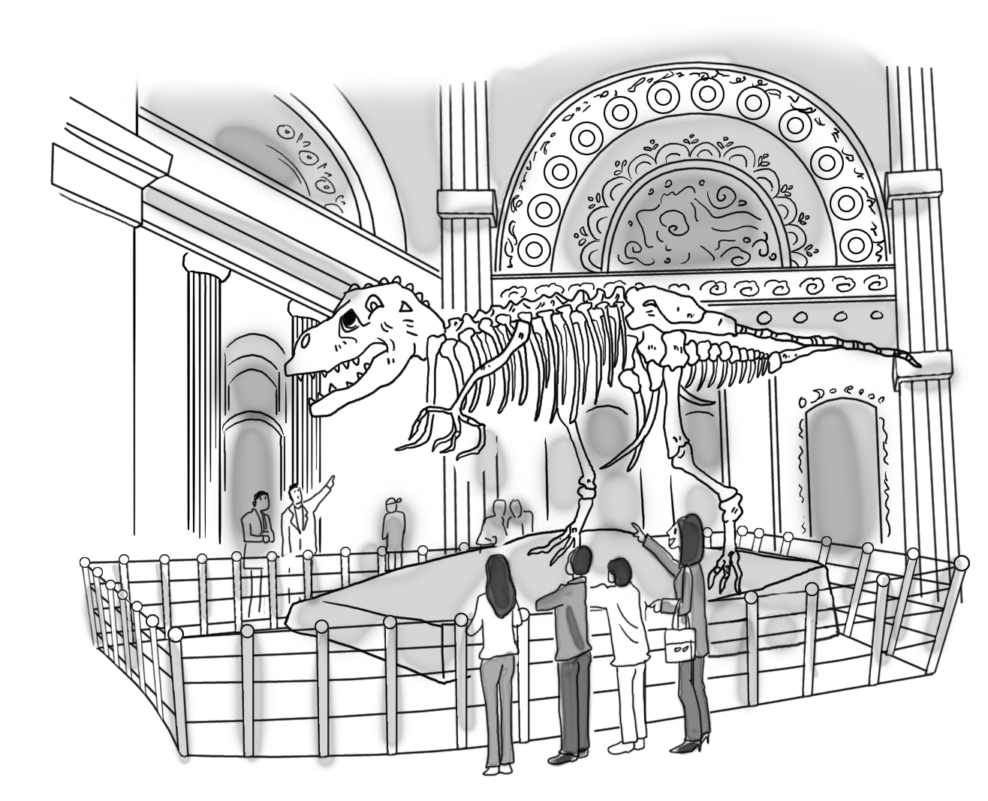
A. B. C.

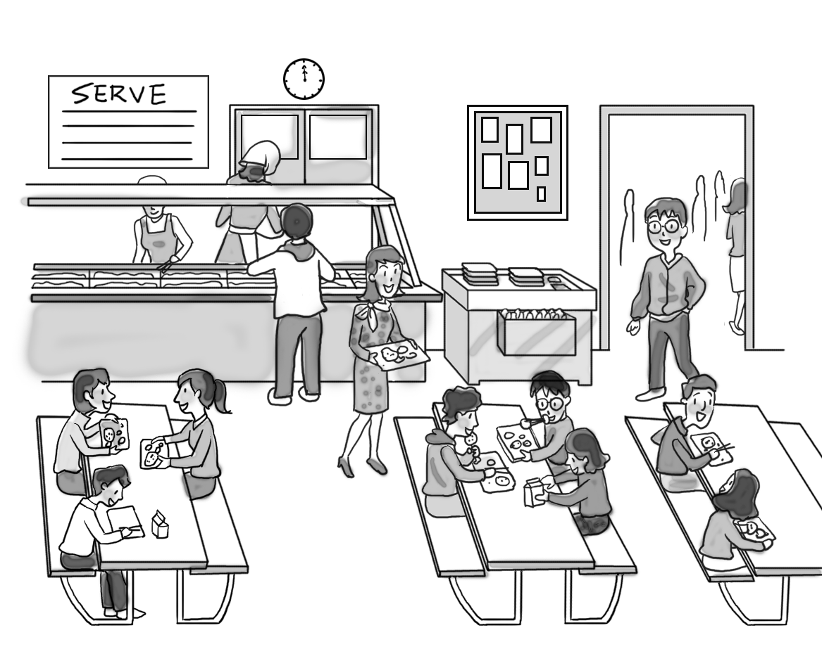

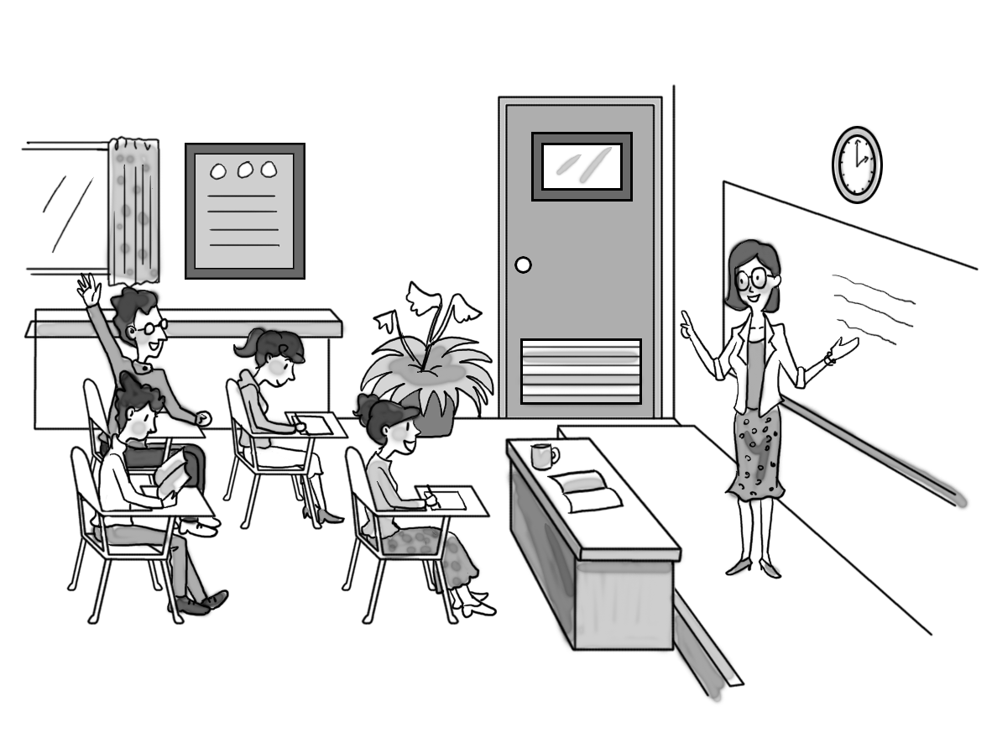
9._____
Part B 18%
In part B, you will hear several questions or statements. Choose the best response or reply.
10. (A) We should get a new factory.
(B) We must make more sales.
(C) We will get a new boss tomorrow.
(D) We need some pens and paper.
11 (A) They’ll record some new music today.
(B) They’ll release a new record in May.
(C) They threw out their CDs yesterday.
(D) They will play a concert next weekend.
12. (A) I have a pain in my leg.
(B) I don’t want people to hear me.
(C) I haven’t had lunch yet.
(D) So my parents will be proud.
13. (A) Most clothes are made in Asia.
(B) I buy my clothes at a small shop.
(C) Bright colors are popular now.
(D) I’m wearing jeans and a T-shirt.
14. (A) How was the party?
(B) When did it take place?
(C) Oh, I didn’t know it’s coming up.
(D) I don’t see anyone coming toward us.
For Questions 15-18, listen to the following questions or statements, and then read the THREE possible responses. Choose the most appropriate response for each question.
15. (A) I know a little Chinese.
(B) Very much.
(C) It’s nice to meet you.
16. (A) I had no idea it was there!
(B) It’s on the third floor.
(C) It’s in my bag.
17. (A) Yes, I have one.
(B) Yes, it’s the best way to get there.
(C) Yes, she will meet me there.
18. (A) Go to the fourth floor.
(B) Walk along First Avenue for two blocks.
(C) I am a DJ in my home country.

Part C 14%
In part C, you will hear one or more conversations between a man and a woman, and then a question following each conversation. Choose the best answer to that question.
19. (A) Because he had a fight with his friend.
(B) Because Jane wouldn’t date him.
(C) Because he had a bad day at work.
(D) Because Jane broke up with him.

20. (A) The news programs.
(B) The bad actors and actresses.
(C) The boring shows.
(D) The advertisements.
21. (A) Excited and happy.
(B) Angry and upset.
(C) Shocked and surprised.
(D) Bored and tired.
22. (A) He called Tom and yelled at him.
(B) He decided to give the bike to Tom.
(C) He promised to buy a new bike for the woman.
(D) He stopped the woman from going to Tom.
23. (A) She will only go if the man is going.
(B) She won’t go to the concert.
(C) She will certainly go to the concert.
(D) She will likely go to the concert.
24. (A) Kenya.
(B) Taiwan.
(C) Denmark.
25. (A) No, she is cold.
(B) Yes, she is all right.
(C) No, she will see a doctor.
Part D 10%
In part D, you will hear one or more short talks and then some questions about them. Choose the best answers to those questions.
Short Talk 1
26. (A) He hosts World’s Most Dangerous Jobs.
(B) He flies 250 feet above the ground.
(C) He runs a distance of 2,000 feet.
(D) He does things that aren’t safe.
27. (A) Nik won’t be connected to the cable.
(B) Nik won’t be anywhere near the cable.
(C) Nik will jump off the cable.
(D) Nik will swing from the cable.
28. (A) To talk about working in different conditions.
(B) To introduce someone with a dangerous job.
(C) To talk about people who are really crazy.
(D) To discuss how cables are made.

Short Talk 2
29. (A) He loves to drive in Taiwan.
(B) He moved to Taiwan recently.
(C) He is enjoying his life in Taiwan.
(D) He wants to move away from Taiwan.
30. (A) He is not used to it yet.
(B) It makes him feel excited.
(C) It makes him laugh.
(D) He thinks it’s great.

Part E 40%
Vocabulary
31. My father is the head of _____; he is in charge of all decisions.
(A) immigration (B) household (C) lollipop (D) leather.
32. Vincent becomes a _____ potato during football season.
(A) cottage (B) collar (C) coconut (D) couch
33. In this soap opera, all the actors are dressed in the Qing dynasty _____.
(A) costumes (B) chimneys (C) cabinets (D) carriages
34. In the sale, Chloe picked up a few good _____ at a low price in the mall.
(A) docks (B) bargains (C) flavors (D) laundries
35. The _____ time for this flight to London is at 11:00 p.m. on Mondays.
(A) crispy (B) cabin (C) bacon (D) departure
36. Irene went shopping for her weekly _____ and bought all she needed.
(A) groceries (B) brakes (C) automobiles (D) fireplaces
37. Jane couldn’t go fishing because she didn’t have enough fishing _____.
(A) linen (B) leather (C) march (D) gear .
38. If you put too many pieces of _____, the room will look small.
(A) furniture (B) cheese (C) paper (D) leather
39. Since all the passengers are _____ the plane, the airplane is ready to take off.
(A) abroad (B) broad (C) aboard (D) board
40. Jack gets a weekly _____ of NT$700 from his parents by doing some chores around the house.
(A) chimney (B) biscuit (C) cupboard (D) allowance
41. Food, shelter, clothing and transportation are _____ for living.
(A) essentials (B) fares (C) dyes (D) journeys
42. Wine contains about 10% _____; however, Vodka contains 40%.
(A) cocktail (B) alcohol (C) cheese (D) buffet
43. The online shop offers free _____ to your house on purchases over NT$800.
(A) arrival (B) nap (C) immigration (D) delivery
44. Many young couples have to work, so they share the _____.
(A) necktie (B) fireplace (C) housework (D) blouse

45. The winter is coming. She is _____ a sweater for her son.
(A) dining (B) knitting (C) frying (D) chewing
46. Very often, _____ play an important role in mountain rescue. They can reach remote mountain slopes.
(A) groceries (B) ferries (C) helicopters (D) lollipops
47. The little boy was a victim of _____ violence; he was often hit by his father for no reason.
(A) arrival (B) domestic (C) chewed (D) furnished
48. To keep healthy, we have to _____our bodies with good foods.
(A) brake (B) nourish (C) fry (D) dye
49. My mom orders _____ products directly from the local farm. They are so fresh!
(A) dock (B) dairy (C) diary (D) doze
50. This modern city is quickly developing with new skyscrapers _____ everywhere.
(A) immigrating (B) furnishing (C) flavoring (D) mushrooming
51. Amy took a ______ of the milk tea to see if it was sweet enough.
(A) sip (B) thread (C) spice (D) source
52. In winter, Jessie likes to roll herself up in the _____.
(A) recipes (B) rugs (C) wagons (D) threads
53. Jack has been dreaming of flying an airplane, and becoming a _____ since he was very young.
(A) protein (B) parade (C) poultry (D) pilot
54. The earthquake put back railway _____, so many passengers could not go home by train.
(A) transport (B) wagon (C) robe (D) vehicle
55. Tim’s mom helped him _____ a button on his coat.
(A) shave (B) scrub (C) sew (D) sip
56. A fishing _____ is a boat or ship used to catch fish in the sea, or on a lake.
(A) vessel (B) van (C) vest (D) vinegar
57. According to the recipe, if the beef is tough, it is good to _____ it slowly at low heat.
(A) shave (B) scrub (C) stitch (D) roast
58. Many people use maple _____, a sweetner, in baking pancakes in place of sugar.
(A) spice (B) syrup (C) sleeve (D) sausage
59. Jimmy owns countless pairs of _____ as a form of collection and fashion. He has been collecting shoes for 4 years.
- pancakes (B) sleeves (C) threads (D) sneakers
60. Most _____ come from animals such as dairy, eggs and meat. They can help you lose weight and keep your belly full.
(A) spices (B) cholesterols (C) proteins (D) sauces
61. Acceptable _____ in one culture may not be necessarily suitable in another.
(A) behavior (B) bacon (C) brutality (D) brake
62. Jason is an _____ boss. He is planning to expand his company in foreign countries.
(A) alert (B) ambitious (C) affordable (D) awkward
63. The price of the house is so high that many young people working in Taipei can’t _____ to buy a new one.
(A) adapt (B) accomplish (C) afford (D) awaken

64. Instead of being _____ to animals, we should treat them friendly.
(A) charming (B) clumsy (C) creative (D) cruel
65. Adam was so _____ that he broke his father’s precious vase.
(A) clumsy (B) capable (C) confident (D) courteous
66. The school library is a perfect place for students to _____ on their studies.
(A) conquer (B) charm (C) create (D) concentrate
67. Amy’s mother is a _____ woman. She does not allow Amy to go home after 7 p.m.
(A) conventional (B) conscious (C) courageous (D) cunning
68. Angela could not _____ herself to her position in the new company. She felt stressed out all the time.
(A) bargain (B) adapt (C) chew (D) determine
69. With strong _____, John has decided to work hard to be promoted.
(A) determination (B) conservation (C) immigration (D) creation
70. Many senior high school students in Taiwan are _____ in studies because they want to get admitted to top universities.
(A) cunning (B) dangerous (C) courteous (D) diligent

臺北市立松山高中101學年度第一學期高一第一次段考英語聽講試題解答
1 CBCBA BCABD
11 BBCCB BABBD
21 CDDAC DABCA

31 BDABD ADACD

41 ABDCB CBBBD

51 ABDAC ADBDC

61 ABCDA DABAD

